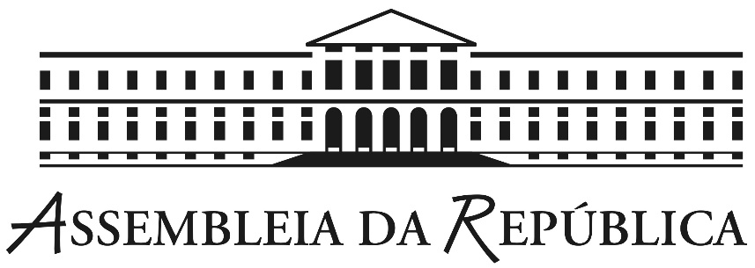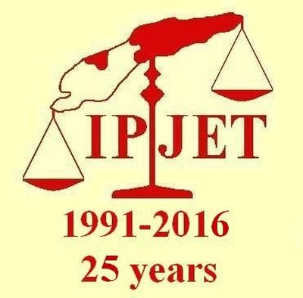

Conference

25 Years of International Platform of Jurists for East Timor

Senate Chamber, Assembly of the Republic, Lisbon, 29 and 30 May 2017

This conference of one and a half day is primarily intended for academics, MPs, civil servants and NGOs, but we also reserved 100 places for law, international relations and political science students.

Simultaneous interpretation available (English-Portuguese-English).
The entrance is free but subject to registration. The participants who register before Thursday 25 may have lunch on Monday 29 and on Tuesday 30 at the restaurant of the Parliament (price: € 14) upon showing their conference badge. Coffee breaks will be served on both days.

Every participant will receive a badge and a carrying case with the bios of the speakers, abstracts of the presentations and a copy of the book 'The East Timor Problem and the Role of Europe'.
To register, please send an email to ipjet25conference@gmail.com with your
- name
- nationality
- title/profession
- institution/organization/university
- mobile number.

Please inform us upon registration
- if you wish to attend both days, or only Monday or Tuesday.
- if you wish to have lunch on both days, or only Monday or Tuesday.

All registrations are subject to availability. Registration is accepted on a first-come, first-served basis. You will receive a confirmation email from us when registration is accepted.

All participants will need to present a photo I.D. to enter the Parliament building.

Program

Monday, 29 May
09.15-09.45 – Registration
09.45-10.00 – OFFICIAL OPENING
Jorge Lacão (Vice-President of the Assembly of the Republic of Portugal)

10.00-10.45 – EAST TIMOR, WESTERN SAHARA AND WEST PAPUA
Emhamed Khadad (MINURSO Coordinator, POLISARIO Front, SADR)
‘The current situation of the UN peace process in the Western Sahara’
Leonie Tanggahma (Member, United Liberation Movement for West Papua, The Hague, The Netherlands)
‘West Papua, an issue whose time has come’

10.45-11.15 – Coffee break

11.15-12.00 – THE STRUGGLE AGAINST IMPUNITY
Gustavo Gabriel Lopez (Attorney, Cañuelas, Argentina)
‘Impunity, NEVER AGAIN’
Sisto dos Santos (Advocacy coordinator, HAK Association, Timor-Leste)
‘Timor-Leste: between the struggle for truth and effort to forget the past’

12.00-12.30 – SUPPORTING DEMOCRACY AND JURIDICAL INSTITUTIONS
Cristina Cruz (Council member, CIDAC, Lisbon, Portugal)
‘Reflections on the role of civil society’

12.30-15.45 – Lunch break (and meeting for IPJET members)

15.45-16.30 – SOVEREIGNTY OVER NATURAL RESOURCES
Joaquim da Fonseca (Ambassador of Timor-Leste to the United Kingdom)
‘Timor-Leste and the sovereignty over its natural resources’
Charles Scheiner (Researcher, La’o Hamutuk, Timor-Leste)
‘Timor-Leste's oil wealth: financing government, building for development and providing for its people’

16.30-17.00 – Coffee break

17.00-18.30 – DEBATE AMONG THE PARTICIPANTS
Free interventions

18.30-19.00 – KEYNOTE SPEAKER
Xanana Gusmão (Minister of Planning and Strategic Investment, Timor-Leste) (to be confirmed)

Tuesday, 30 May

09.30-11.00 – INTERNATIONAL LAW AND SELF-DETERMINATION
Christine Chinkin (Professor of International Law, London School of Economics, UK)
‘Women’s Human Rights in Timor Leste and Western Sahara’
Roger Clark (Board of Governors Professor, Rutgers School of Law, USA)
‘East Timor and West New Guinea: Comparing the Arguments for Self-Determination at the United Nations’
Lauri Hannikainen (Emeritus Professor of International Law, Helsinki, Finland)
'Suppression of East Timor's right of self-determination: how gross was the violation of international law? Comparisons with the cases of Palestine and Western Sahara'

11.00 – 11.30 – Coffee break

11.30-12.30 – CLOSING SESSION: IPJET, PAST WORK AND ACHIEVED GOALS
José Manuel Pureza (Vice-President of the Assembly of the Republic of Portugal)
‘Who saved East Timor: resistance, cosmopolitanism and diplomacy’
Rui Moura Ramos (Professor of International Private Law, University of Coimbra)
Pedro Pinto Leite (International lawyer, secretary of IPJET, Leiden, the Netherlands)
‘Recalling the start of IPJET and remembering our deceased members’

*****
This conference is made possible thanks to the generous support of:
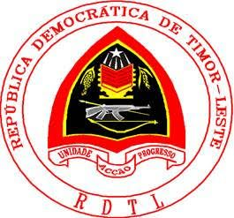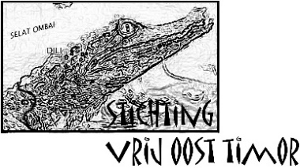
Embaixada da República Democrática Free East Timor Foundation (NL) Timor-Leste Institute for
de Timor-Leste em Portugal Development
Monitoring and Analysis
